Cover Letter as an Email
When preparing a letter to accompany your resume/CV, it may be appropriate to send your letter as an email versus attaching it to an email as a Word.doc or PDF.
Here is an example of how such an email letter might look when prepared.
Note:
- The prospective employer’s company and address go on the first few lines.
- Your personalized signature line with educational information and contact information goes at the bottom.
Have you created a signature line on your ONU (Google) email? To learn more about this, see “Email Signature Line Tips” which can be downloaded from the Document Library when you log into the Polar Careers _{powered by Symplicity}. Start now and create a signature line for use with all email correspondence. It will help you to be perceived as a professional in your field throughout your college career and beyond.
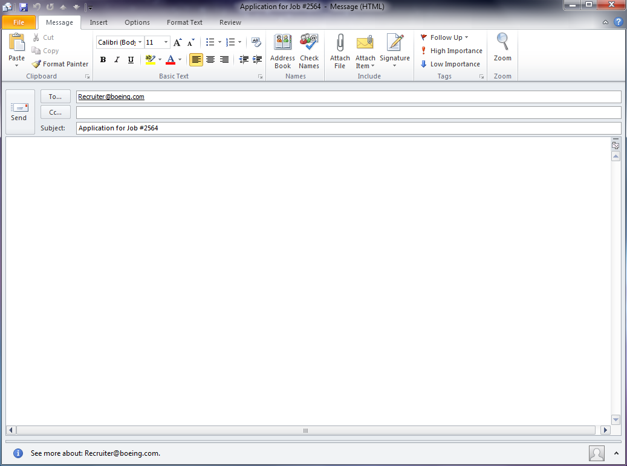
Boeing Employment Office
P.O. Box 3707, M/S 6H-PL
Seattle, WA 98124
Good Morning;

Please consider me as a candidate for a Simulation Software Design Engineering position. As my attached resume details, I am currently receiving training on virtual simulation software and I will take part in a national research effort to develop curriculum for teaching such an application later this year. I am very interested in virtual simulation and other state-of-the-art technologies, such as automation and robotics. These interests, coupled with an educational and industrial background in the application of technology, allow flexibility in today's constantly changing industry.

I will receive my Bachelor of Science degree, majoring in advanced manufacturing, from Ohio Northern University in May 2xxx, and will be available for employment at that time. In addition to my coursework, my undergraduate studies include a design analysis option, which consists of many classes taken from the College of Engineering. I also served as an intern for three companies, which provided me with a diverse background of experience in many areas of engineering.

An internationally recognized and respected company, it is obvious that Boeing continues to be committed to product development and current technology. I am a highly motivated, ambitious, and mobile person with the drive to achieve my goal. My goal is to be a valued member of the Boeing team.

I would like an opportunity to further discuss my qualifications with you. I am available at your convenience for an initial interview by phone or any other method of communication that you may prefer. I look forward to communicating with you.

Sincerely yours,
Michael Brown
Bachelor of Science, Technological Studies, May 2xxx | OHIO NORTHERN UNIVERSITY
C: 914.269.7588 | E: m-brown.2@onu.edu | http://www.linkedin.com/in/mbrown.2

