**Ohio Means Internship Search Guide**

Are you looking for a paid summer internship in the field of biological or chemical sciences?

If so, please visit the following website to view available opportunities:

[www.ohiomeansinternships.com](http://www.ohiomeansinternships.com)

Follow these **FIVE** key steps:

1) Click on the “**Search for internships**” link under the Students heading.

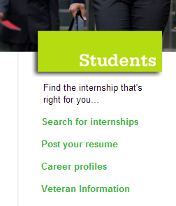***Note:  You can still search for internships, without setting up an account or posting a resume!!***

1

2)Click on the **“Profile”** tab to set up an account.

***Note:  Use your Lourdes University e-mail account when developing the account***

32

422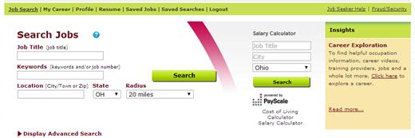

3) Click on the “**Post a resume”** and follow the instructions to share your resume with employers

***Note:  Before you post it, visit Lourdes University Career Services for a resume critique or for resources on resume writing.***

4)Search the available internships by **Keywords:**  ***lab, science, biology, research, etc.***

5) Click on the **“Save this search and e-mail me jobs”** to receive e-mails withinternship opportunities that meet your designated criteria.

5

